**ID: bvarshsp**

**Name: Varsha SP**

**Day 6 – 29th May 2025**

**Task 1:**

RegEX Symbols in linux

List them down with description

Answer:

. matches any single character

*matches 0 or more occurrences of the previous character

+ matches 1 or more occurrences of the previous character

? matces 0 or 1 occurrence of the previous character

^ matches start of a line

$ matches end of a line

[] matches any 1 character inside the brackets

[^] matches any character not inside the brackets

() groups expressions together

**Task 2:**

What are the imp features of Linux os ?

6 min 9.48 to 9.54

Answer:

* Free and Open Source: The source code is freely available, allowing for transparency, community development, and customization.
* Multitasking and Multiuser Capacity: Linux supports multiple users and allows them to run multiple applications simultaneously.
* Security: Linux offers a strong security model, with built-in user privilege control, strict file access, and strong authentication features.
* Lightweight Infrastructure: Many Linux distributions are designed to be lightweight and efficient, making them suitable for resource-constrained devices..
* Package Management: Linux uses package managers to simplify the installation, update, and removal of software.
* Frequent New Updates: Linux benefits from regular updates that provide security patches, bug fixes, and new features.
* networking: Linux has strong networking capabilities, with support for various protocols and network services.
* portability: Linux can run on a wide range of hardware, from embedded systems to powerful servers.

**Task 3:**

WHAT IS Kernal and can you explain its functions

5 min 9.55 to 10.00

Oral also for rating

Answer:

A kernel is a computer program at the core of a computer's operating system that always has complete control over everything in the system.

It’s responsible for managing our system resources, running processes, and communicating with the hardware.

It controls how applications interact with hardware devices like disks or keyboards and handles the communication between applications and the hardware.

**Task 4:**

What is BASH? Full form with explaination.

5min 10.00 to 10.05

Answer: BASH stands for Bourne Again SHell. It is a command-line interpreter and scripting language used on Unix-like operating systems. It is a powerful tool that allows users to interact with the operating system through a command-line interface, allowing users to perform various tasks and also automate them through commands and scripts.

**Task 5:**

What is the diffrenece between window and linux

5 min 10.20 to 10.25

Answer:

Differences between Windows and Linux:

Windows: closed source, paid, GUI focused, customization is limited, more vulnerable to malware and viruses, resource usage is more, functionality is limited (PoweShell, CMD), mostly used by gamers, home users.

Linux: open source: open resource, free (optional paid support), GUI+CLI focused, highly customizable, more secure/fewer viruses, lightweight and efficient, advanced tools(bash, awk, sed, etc), used by developers, sysadmins, servers.

**Task 6:**

Define the basic components of Linux

10.25 o 10.30

Answer:

The core components of a Linux operating system include the kernel, system libraries, and system utilities.

kernel: This is the core of the Linux operating system, directly interacting with the hardware. It manages resources, processes, and memory, ensuring efficient operation of the system.

System Libraries: These libraries provide a set of functions that applications can use to perform various tasks without directly interacting with the kernel.

System Utilities: These are programs that perform specific tasks at the system level, such as managing files, users, and system resources. They are also used for administrative tasks like installing software or configuring the system.

**Task 7:**

Is it legal to edit Kernal?

2 min 10.31 to 10.33

Answer: Yes, it is legal to edit Linux Kernel provided we comply with the GNU General Public License (GPL). Linux is released under the General Public License (GPL) and any project which is released under GPL can be edited & modified by the end users.

**Task 8:**

how many of you have gone through techadamy Linux plz raise ur hand

16 pax done out of 29

Can you explain LILO

10.34 to 10.40 6 min

Answer: LILO, Linux Loader, is an older bootloader used in Linux systems to load the operating system into memory during the boot process. It's responsible for loading the kernel and initial RAM disk (initrd).

**Task 9:**

What is shell? How many shells are there and what are they ? can you explain.

10.41 to 10.51 10 min

Answer: A shell is a program that provides a user interface for interacting with an operating system. It acts as a command-line interpreter, taking user input, interpreting it, and executing the corresponding actions.

There are two main categories of shells: command-line shells (CLI) and graphical shells (GUI).

Command-line Shell (CLI): It allows interaction with the operating system through text-based commands. Examples: Bourne shell (sh), C shell (csh), Z shell (zsh). It provides a text-based interface where users can enter commands and receive output in a similar format.

Graphical Shell (GUI): It provides a graphical user interface, making interaction with the operating system easier and more intuitive. Examples: Windows Explorer, GNOME. It uses icons, menus, and windows to allow users to interact with the operating system visually.

**Task 10:**

What is Swap space ?

2 min 10.52 to 10.54

Answer: Swap space, also known as virtual memory, is a storage area on a computer's hard drive that acts as an extension of its physical RAM. It's used when the RAM is full, temporarily storing inactive data that is not immediately needed, preventing system crashes due to memory shortages.

**Task 11:**

What is Mount ? how do you mount and unmount file system in Linux?

10 min 10.55 to 11.05

Plz raise hand once done till here.. So that we can go for oral..

Oral - random pick only few.. By the Facilitator/trainer.

Answer: In Linux, "mount" refers to attaching a filesystem (like a hard drive partition, a USB drive, or a network share) to the directory structure, making its contents accessible. Conversely, "unmount" means detaching the filesystem, removing it from the directory structure and making its contents inaccessible.

Mounting a File System:

Identify the device file (e.g., /dev/sda1) corresponding to the filesystem you want to mount. (We can often find this using ls -l /dev/disk/by-label if the filesystem has a label.)

Create a mount point: Create a directory where the filesystem will be attached (e.g., /mnt/my_drive).

Mount the filesystem: Use the mount command, specifying the device and the mount point:

Example Code:

sudo mount /dev/sda1 /mnt/my_drive

sudo umount /mnt/my_drive

**Task 12:**

What is chmod command ? how to use it?

5 min

Answer: The "chmod" command modifies the read, write, and execute permissions of specified files and the search permissions of specified directories. It allows us to control who can read, write, and execute files, and who can search or use directories in path names.

[who] refers to who you are giving permissions to. Specified in the order: user, group, others. The permissions that can be given are: read, write or execute.

examples:

chmod u+x file.sh: Adds execute permission for the user to the file file.sh.

chmod g-w directory: Removes write permission for the group from the directory.

chmod o=r directory: Sets the permissions for others to read the directory.

chmod a+r file.txt: Adds read permission for all users to the file file.txt.

**Task 13:**

Can you add a new user account? Crate a new user in different ways and paste ss

5 min

Answer:

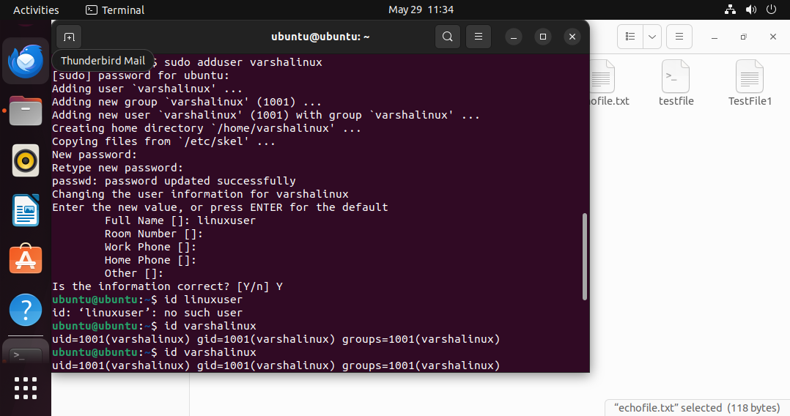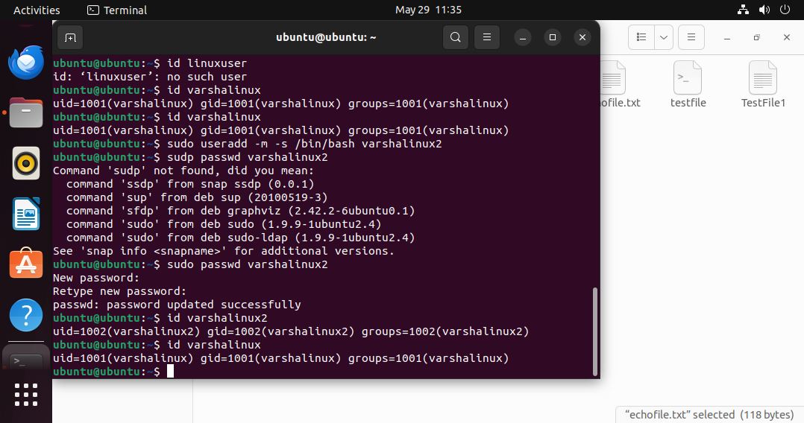

**Task 14:**

Can you change the password of a user?

How do you do that? Plz share ss

5 min

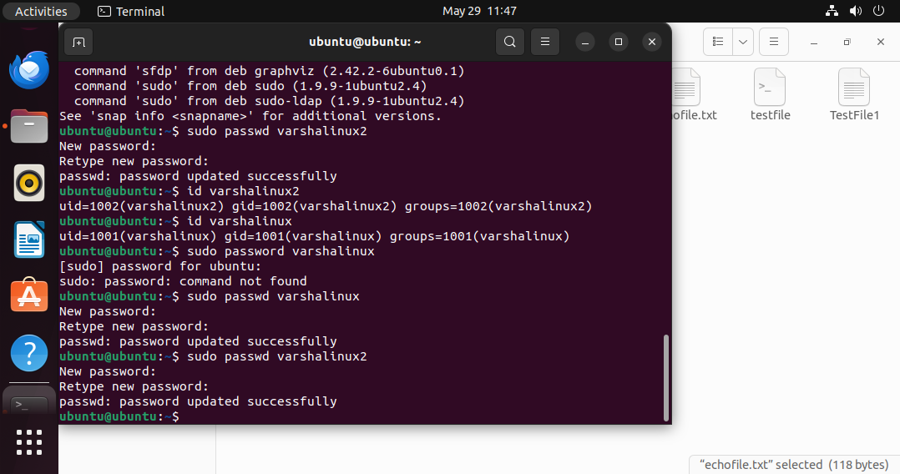

**Task 15:**

What is diff between Process and Thread?

Plz explain

8 min

Answer:

Process and threads are the basic components in OS. Process is a program under execution whereas a thread is part of process. Threads allows a program to perform multiple tasks simultaneously, like downloading a file while you browse a website or running animations while processing user input.

A process can consists of multiple threads. They are basically the programs that are dispatched from the ready state and are scheduled in the CPU for execution. It can create other processes which are known as Child Processes. The process takes more time to terminate, and it is isolated means it does not share the memory with any other process.

Threads are often called "lightweight processes" because they share some features of processes but are smaller and faster. Each thread is always part of one specific process.

**Task 16:**

Doc 14 Linux Grep commands .. plz work on it..

12.03 to 12.13 to 12.18

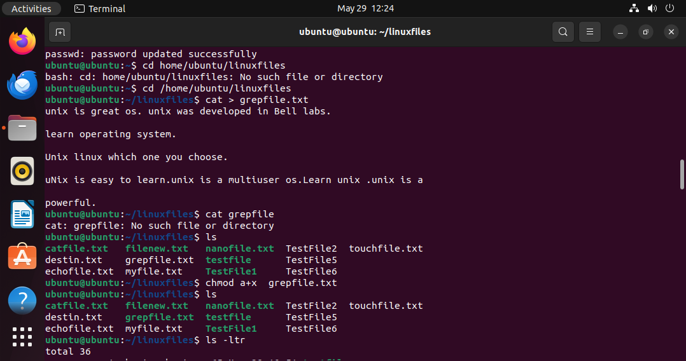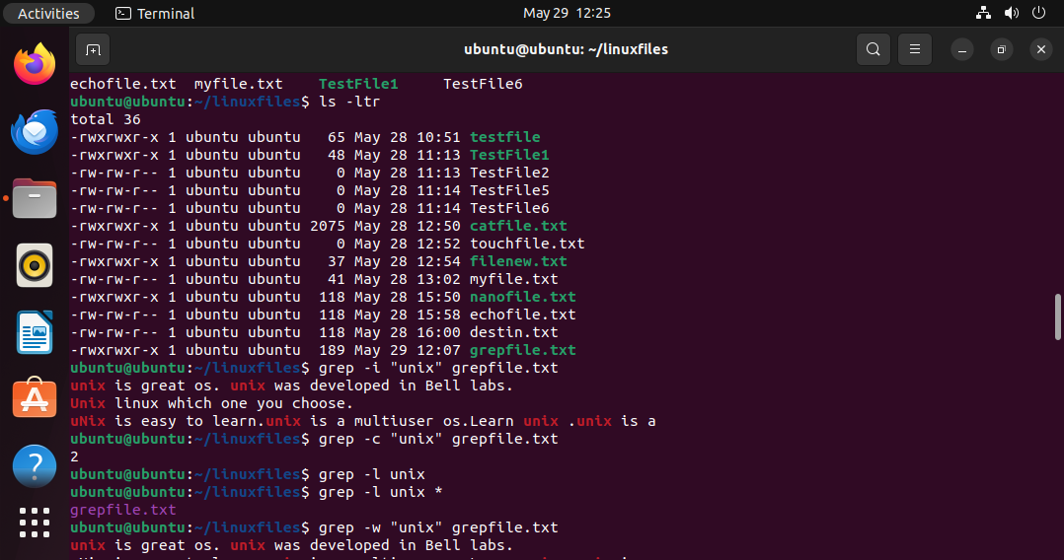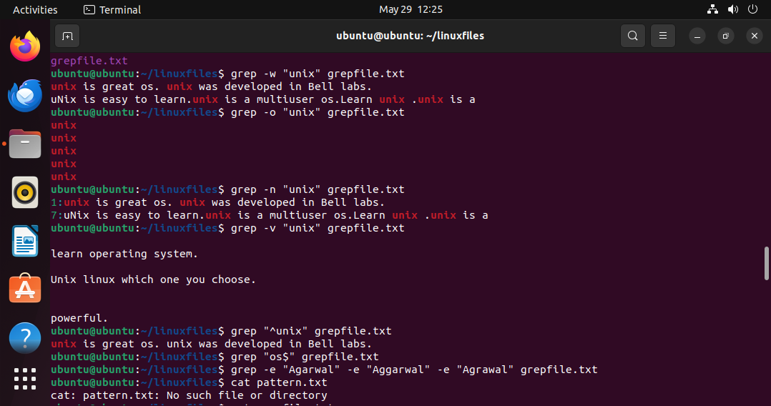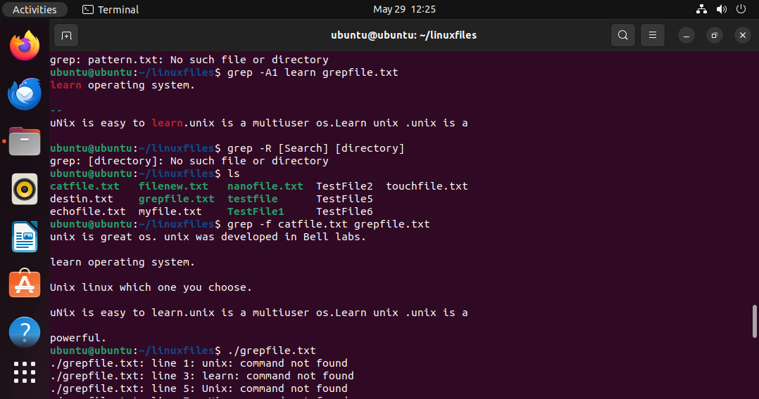

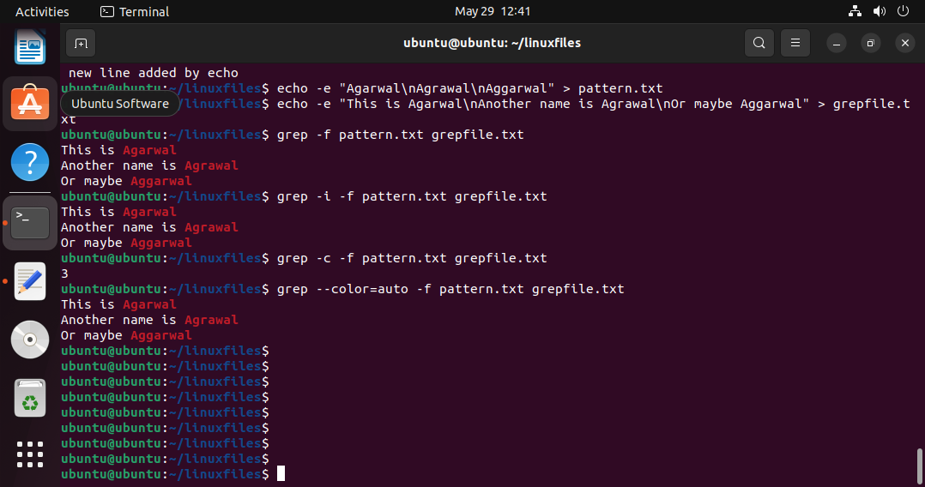

**Task 17**

AWT commands in doc 15 Linux AWT commands..

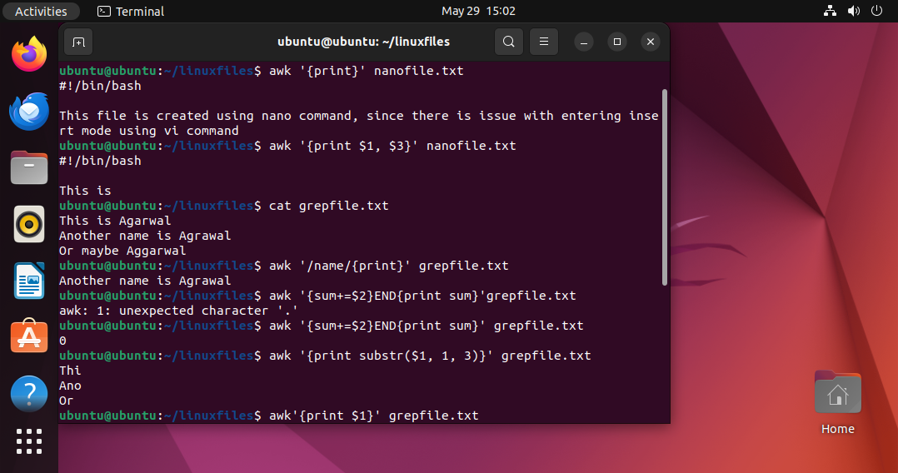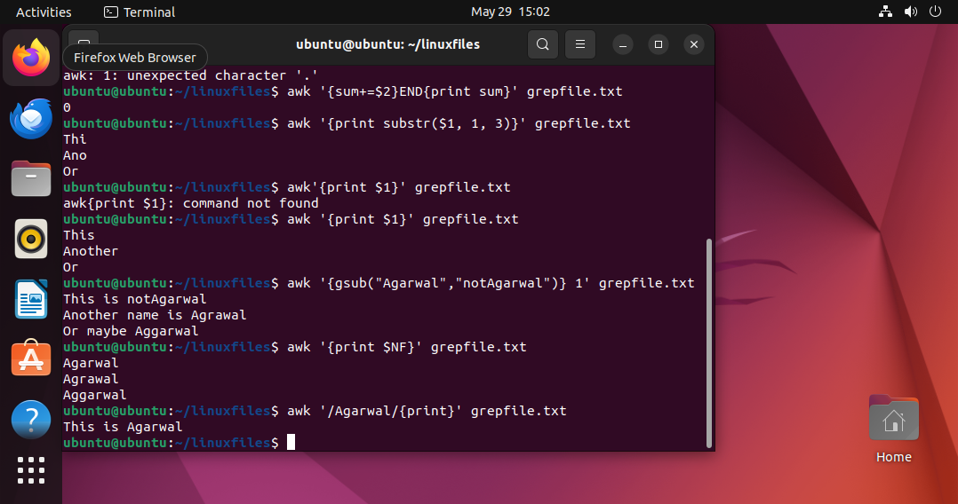

**Task 18:**

How to check file access permission in Linux?

Answer: We use ls -l command to check file access permissions. (read r, write w, and execute x)

(Screenshot attached after task 22)

**Task 19:**

What are the default permissions for a new file ?

Plz find out for

Owner   → ?

Group → ?

All and others → ?

Juz write no ss req

Answer:

The default permissions in Linux for owner, groups and all others are Read and Write.

**Task 20:**

What is the command to change the permisssion to read only for the owner, group and all other users?

Answer: chmod 444 filename

(Screenshot attached after task 22)

**Task 21:**

Can you change the file permissions to match the following:

* owner: Read and Write
* group: Read
* other: no permissions (None)

Answer:

Chmod u=rw,g=r,o= filename

chmod 640 filename

Owner: 6=4+2: read+write

Group: 4: read-only

Others: 0: no permission

(Screenshot attached after task 22)

**Task 22:**

What was the command for changing teh file permissions to -rw-r-----?

Answer: chmod 640 filename

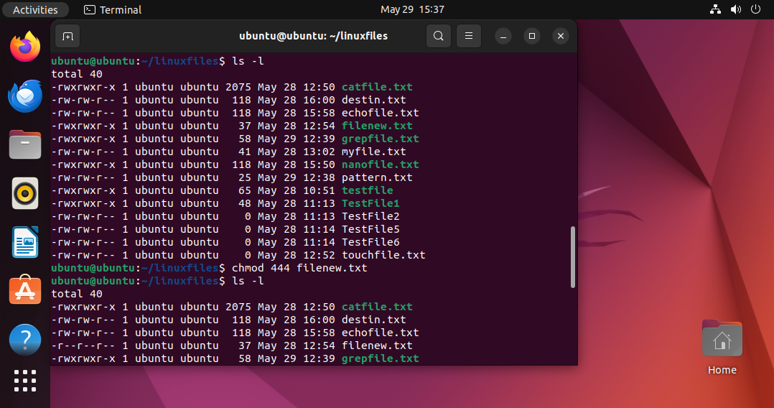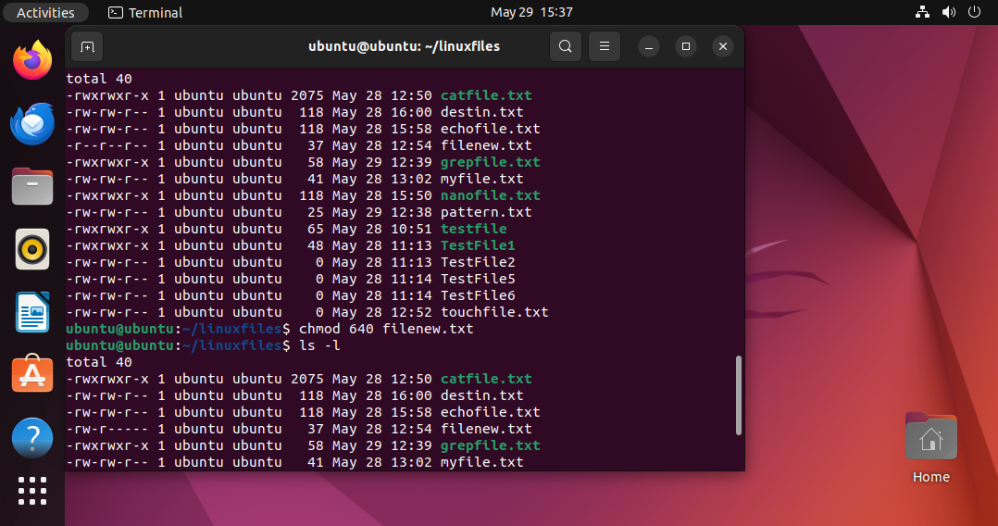

**Task 23:**

Change chmod.exercises permissions to -rwxr-x--x

Change the file permissions to match the following:

owner: Read, Write and Execute

group: Read and Execute

other: Execute

Answer:

Chmod u=rwx,g=rx.0=x filename

chmod 751 filename

Owner: 7=4+2+1: rwx

Group: 5=4+0+1: r-x

Others: 1=0+0+1

**Task 24:**

What was the command for changing the file permissions to -rwxr-x--x

Answer:

chmod 751 filename

**Task 25:**

Guys what will this command do?

chown -c master file1.txt

Answer: It changes the ownership of a file or directory.

c: changes, it reports when a change is made

master: new owner of the file

file1.txt: target file whose ownership has to be changed

we can also use this: sudo chown -c master file1.txt

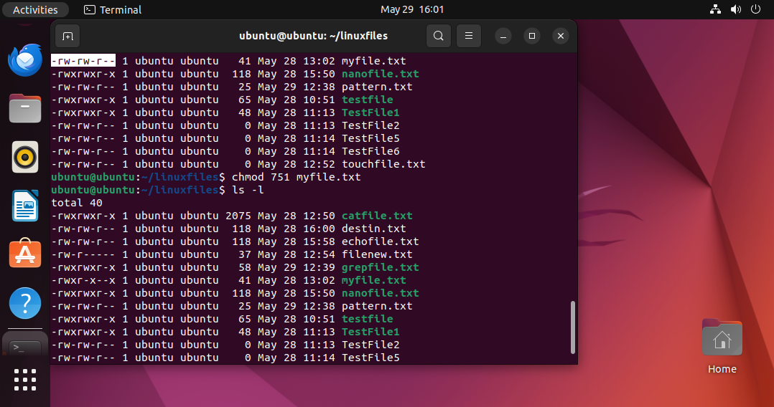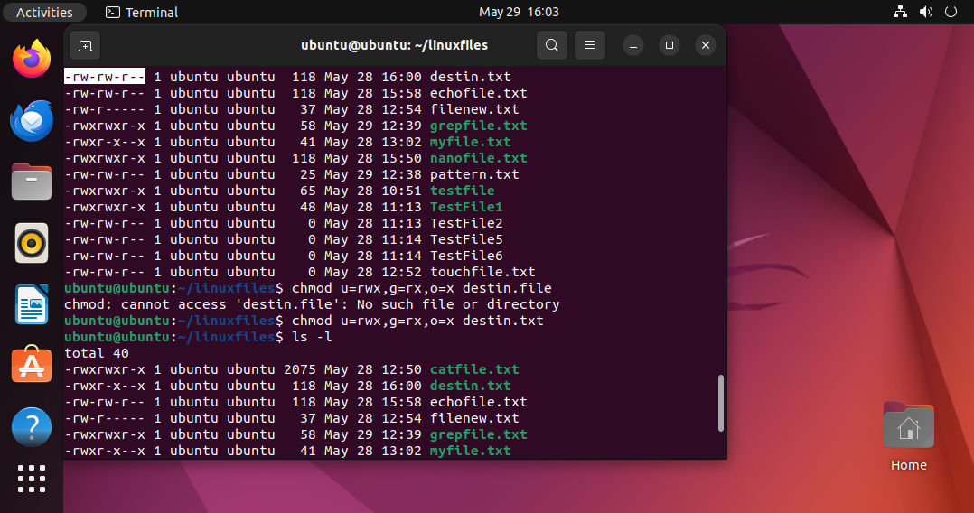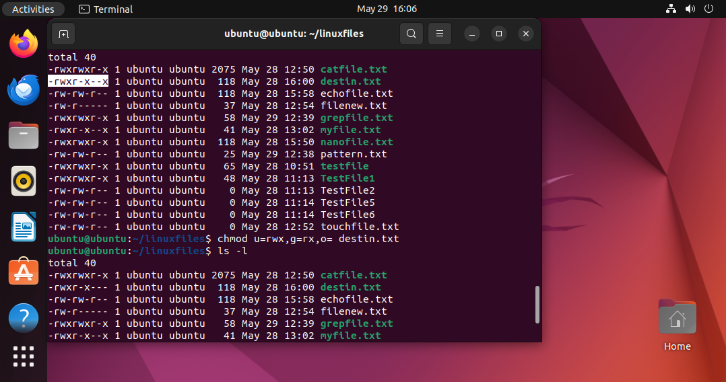

**Task 26:**

Can you define what is  a process

answer: Process is an instance of a running program. Every time we run a command or execute a script, a new process is created.

**Task 27:**

What is command to check foreground process and background process

Foreground process: Runs in terminal and waits for user input.

Background process: Runs behind the scenes without blocking the terminal.

Command: jobs

**Task 28:**

Can you list all the running processes?

Hint use ps

Answer: Yes,

command:

ps aux

ps -ef

**Task 29:**

What will ps -f command do ? plz try n check .. ss required.

Answer: It will show processes in full-format listing, buy only for the current user’s shell session by default.

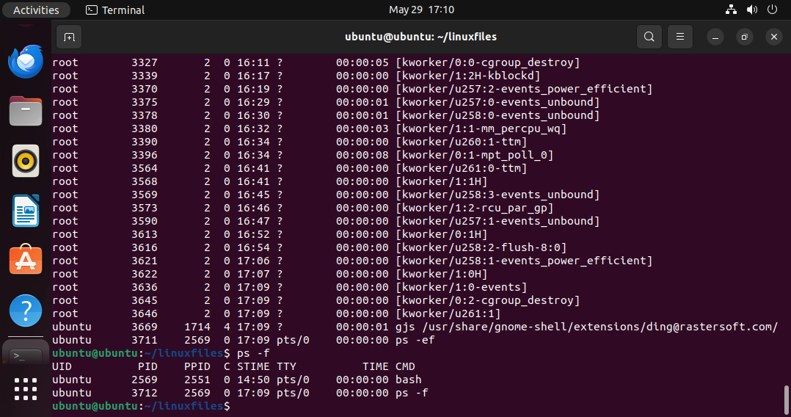

Let’s play with shell variables

**Task 30:**

Can you createa  a variable name with your name in it

Ex:

Name =  “prasunamba”

Id  = 10001

And check

Echo $Name

Chek the output

Answer screenshots attached

Answer: All the variables related tasks from Task 30 to Task 35, I have attached answer screenshots in the end. Please refer to them.

**Task 31:**

Can you make the above name variable read only..

Ex:

Name = “Prasunamba”

Readonly Name

Name = “Meher” —>what will this display.. Is it saying read only?? Pl check

Answer: Yes it says readonly name cannot be changed

Answer: All the variables related tasks from Task 30 to Task 35, I have attached answer screenshots in the end. Please refer to them.

**Task 32:**

Now will unset or delete the variables

Use the below command and check

Unset Name

Now check for

 echo $Name   —> this should not print anything.. Plz try also specify the reason

Answer: If variable is marked readonly previously, it will fail. The variable still exists and will still print. We can unset and then try echo.

Answer: All the variables related tasks from Task 30 to Task 35, I have attached answer screenshots in the end. Please refer to them.

**Task 33:**

CAn u try to add a list of your friends names in an array and try to printout

Ex:

NAME[0]="Ram"

NAME[1]="Sita"

NAME[2]="Tina"

NAME[3]="Veena"

NAME[4]="Tim"

echo "First Index: ${NAME[0]}"

echo "Second Index: ${NAME[1]}"

Answer screenshots attached

Answer: All the variables related tasks from Task 30 to Task 35, I have attached answer screenshots in the end. Please refer to them.

**Task 34:**

Can you print all the list at once in an array.. Try the below cmds and check

Echo “${array_name[*]}”

Echo “${array_name[@]}”

Answer: Both produce same visible output, but behave differently.

“${array_name[*]}” : expands all elements as one string

“${array_name[@]}” : expands each element as a separate string

Answer: All the variables related tasks from Task 30 to Task 35, I have attached answer screenshots in the end. Please refer to them.

**Task 35:**

Plz let me know whats the output of the below snippet:

a=0

while [ "$a" -lt 10 ]    # this is loop1

do

   b="$a"

   while [ "$b" -ge 0 ]  # this is loop2

   do

      echo -n "$b "

      b=`expr $b - 1`

   done

   echo

   a=`expr $a + 1`

Done

Answer:

It prints a number pattern: screenshot attached

Answer: All the variables related tasks from Task 30 to Task 35, I have attached answer screenshots in the end. Please refer to them.

Output Screenshots:

